LAB EXPERIMENTS
NAME: Y.SAI PRASANTH VARMA REGISTRATION NUMBER:192411191
COURSE NAME: INTERNET PROGRAMMING
COURSE CODE: CSA4308
1. A local library needs a website to streamline operations and enhance user experience. The site will include a catalog for searching and viewing books, user accounts for borrowing and managing books, and an admin dashboard for managing inventory and user data. Essential features include a search function, book details page, user login system, and contact form, The system helps both students and library managers to keep constant track of all the books available in the library. It allows both the admin and the student to search for the desired book.It becomes necessary for colleges to keep a continuous check on the books issued and returned and even calculate fines.
Source Code:
<!DOCTYPE html>
<html>
<head>
<title>Library Management System</title>
</head>
<body>
<h1 align="center">Library Management System</h1>
<hr>
<h2>Search Book</h2>
<input type="text" placeholder="Enter Book Name">
<button>Search</button>
<hr>
<h2>Student Login</h2>
<form>
Username: <input type="text"><br><br>
Password: <input type="password"><br><br>
<input type="submit" value="Login">
</form>
<hr>
<h2>Book Details</h2>
<table border="1" cellpadding="5">
<tr>
<th>Book ID</th>
<th>Book Name</th>
<th>Author</th>
<th>Status</th>
</tr>
<tr>
<td>101</td>
<td>Java</td>
<td>Herbert Schildt</td>
<td>Available</td>
</tr>
<tr>
<td>102</td>
<td>Python</td>
<td>Mark Lutz</td>
<td>Issued</td>
</tr>
</table>
<hr>
<h2>Contact</h2>
<form>
Name: <input type="text"><br><br>
Message:<br>
<textarea rows="4" cols="30"></textarea><br><br>
<input type="submit" value="Send">
</form>
</body>
</html>
Output:
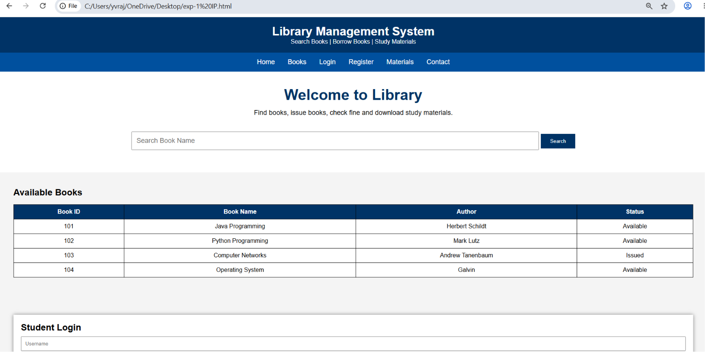
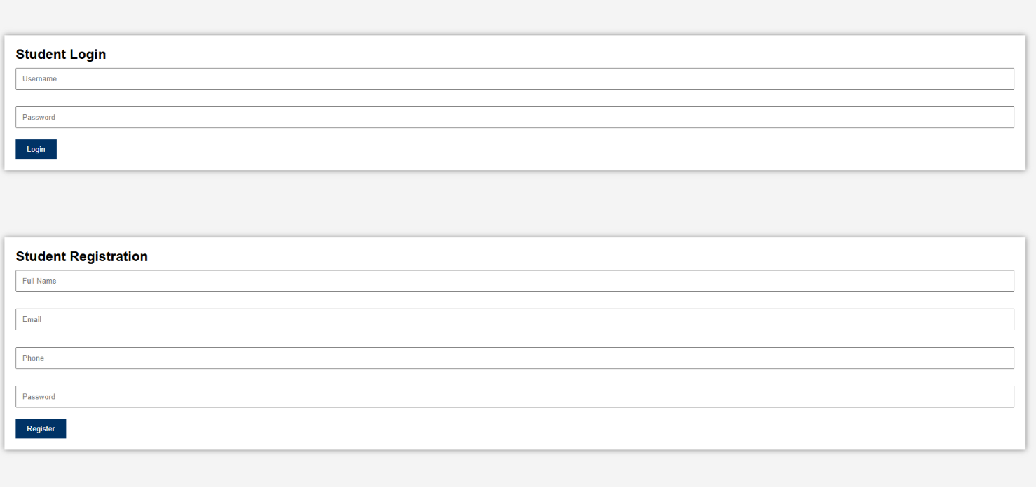
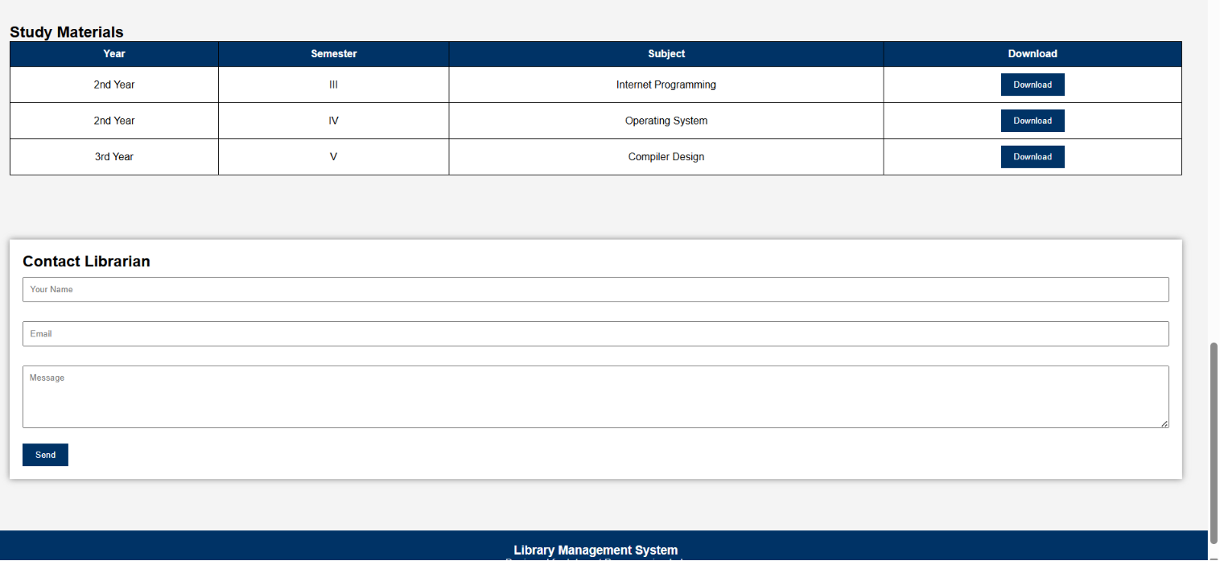
2. The online hotel room booking website allows users to search for hotels based on destination,dates, and number of guests, offering detailed listings with room options, prices, amenities, an reviews. Users can create accounts, log in, and manage their bookings through a user-friendly dashboard. The booking process includes checking room availability, filling out a booking form, and completing secure payments via an integrated payment gateway. Post-booking, users receive confirmation emails and can leave reviews and ratings. Admins manage hotel listings, room availability, and user accounts through a dedicated admin panel. The website is fully responsive, ensuring seamless access on all devices.
Source Code:
<!DOCTYPE html>
<html>
<head>
<title>Hotel Room Booking</title>
</head>
<body>
<h1 align="center">Hotel Room Booking System</h1>
<hr>
<h2>Search Room</h2>
<form>
Destination: <input type="text"><br><br>
Check-in: <input type="date"><br><br>
Check-out: <input type="date"><br><br>
Guests: <input type="number"><br><br>
<input type="submit" value="Check Availability">
</form>
<hr>
<h2>Available Rooms</h2>
<table border="1" cellpadding="5">
<tr>
<th>Room Type</th>
<th>Price</th>
<th>Status</th>
</tr>
<tr>
<td>Single</td>
<td>₹1500</td>
<td>Available</td>
</tr>
<tr>
<td>Double</td>
<td>₹2500</td>
<td>Available</td>
</tr>
<tr>
<td>Suite</td>
<td>₹5000</td>
<td>Booked</td>
</tr>
</table>
<hr>
<h2>Book Room</h2>
<form>
Name: <input type="text"><br><br>
Email: <input type="email"><br><br>
Room Type:
<select>
<option>Single</option>
<option>Double</option>
<option>Suite</option>
</select><br><br>
<input type="submit" value="Book Now">
</form>
<hr>
<h2>Contact Us</h2>
<p>Email: hotel@example.com</p>
<p>Phone: +91 9876543210</p>
</body>
</html>
Output:
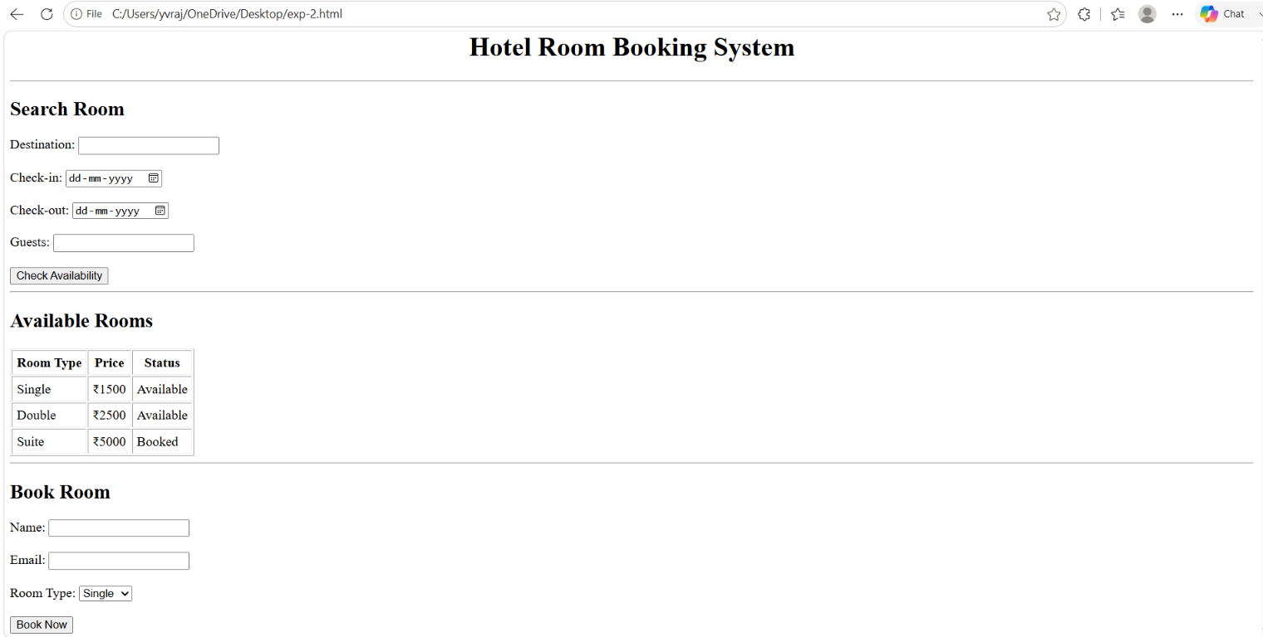
3. The online bus ticket booking system enables users to search for buses by route, date, and time, and view available seats. Users can create an account, log in, and manage their bookings through a personal dashboard. The booking process includes selecting seats, filling out passenger details, and making secure payments via an integrated payment gateway. Admins can manage bus schedules, seat availability, and user accounts through an admin panel. Users receive booking confirmation emails and can view their booking history. The website is mobile- responsive, ensuring easy access on all devices.
Source Code:
<!DOCTYPE html>
<html>
<head>
<title>Bus Ticket Booking System</title>
</head>
<body>
<h1 align="center">Online Bus Ticket Booking System</h1>
<hr>
<h2>Search Bus</h2>
<form>
From: <input type="text"><br><br>
To: <input type="text"><br><br>
Date: <input type="date"><br><br>
<input type="submit" value="Search">
</form>
<hr>
<h2>Available Buses</h2>
<table border="1" cellpadding="5">
<tr>
<th>Bus</th>
<th>Type</th>
<th>Seats</th>
<th>Fare</th>
</tr>
<tr>
<td>Express</td>
<td>Volvo</td>
<td>20</td>
<td>₹800</td>
</tr>
<tr>
<td>Super Deluxe</td>
<td>Sleeper</td>
<td>15</td>
<td>₹1200</td>
</tr>
</table>
<hr>
<h2>Book Ticket</h2>
<form>
Name: <input type="text"><br><br>
Email: <input type="email"><br><br>
Seat No: <input type="number"><br><br>
<input type="submit" value="Book Ticket">
</form>
<hr>
<h2>Comments</h2>
<textarea rows="4" cols="30" placeholder="Write your comments"></textarea><br><br>
<input type="submit" value="Post Comment">
<hr>
<h2>Contact</h2>
<p>Email: support@busbooking.com</p>
<p>Phone: +91 9876543210</p>
</body>
</html>
Output:
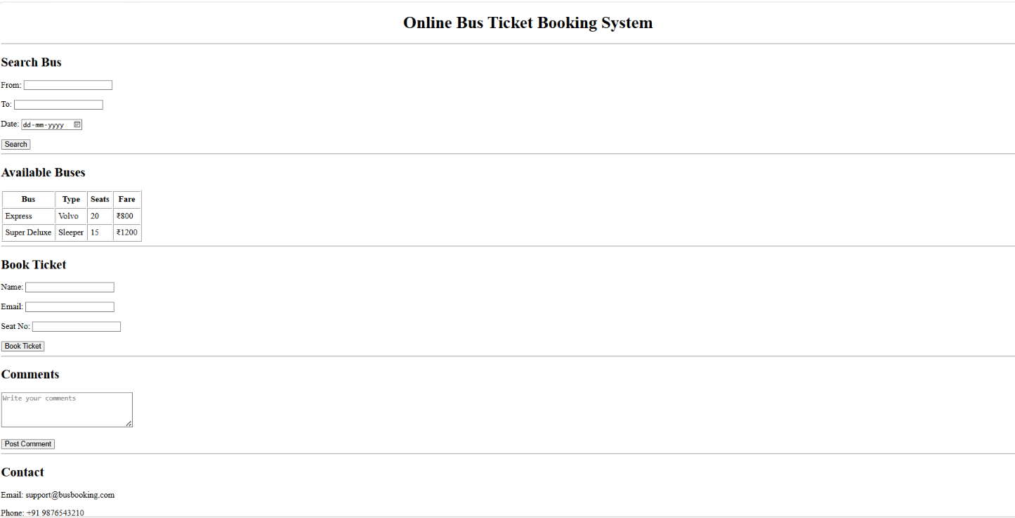
4. The online train reservation system allows users to search for trains by route, date, and time, and view available seats and classes. Users can register, log in, and manage their reservations through a personal dashboard. The booking process involves selecting seats, entering passenger details, and making secure payments via an integrated payment gateway. Admins can manage train schedules, seat availability, and user accounts through a comprehensive admin panel. Users receive booking confirmation emails and can view their booking history and print tickets from their dashboard. The website features real-time seat availability updates and is fully responsive for seamless use on all devices.
Source Code:
<!DOCTYPE html>
<html>
<head>
<title>Train Reservation System</title>
</head>
<body>
<h1 align="center">Online Train Reservation System</h1>
<hr>
<h2>Search Train</h2>
<form>
From: <input type="text"><br><br>
To: <input type="text"><br><br>
Journey Date: <input type="date"><br><br>
Class:
<select>
<option>Sleeper</option>
<option>3A</option>
<option>2A</option>
<option>1A</option>
</select><br><br>
<input type="submit" value="Search Train">
</form>
<hr>
<h2>Available Trains</h2>
<table border="1" cellpadding="5">
<tr>
<th>Train No</th>
<th>Train Name</th>
<th>Seats</th>
<th>Fare</th>
</tr>
<tr>
<td>12615</td>
<td>Grand Trunk Express</td>
<td>45</td>
<td>₹850</td>
</tr>
<tr>
<td>12760</td>
<td>Charminar Express</td>
<td>30</td>
<td>₹650</td>
</tr>
</table>
<hr>
<h2>Book Ticket</h2>
<form>
Name: <input type="text"><br><br>
Age: <input type="number"><br><br>
PNR: <input type="text"><br><br>
<input type="submit" value="Book Ticket">
</form>
<hr>
<h2>Check PNR Status</h2>
<form>
PNR Number: <input type="text">
<input type="submit" value="Check">
</form>
<hr>
<h2>Cancel Ticket</h2>
<form>
PNR Number: <input type="text">
<input type="submit" value="Cancel Ticket">
</form>
<hr>
</body>
</html>
Output:

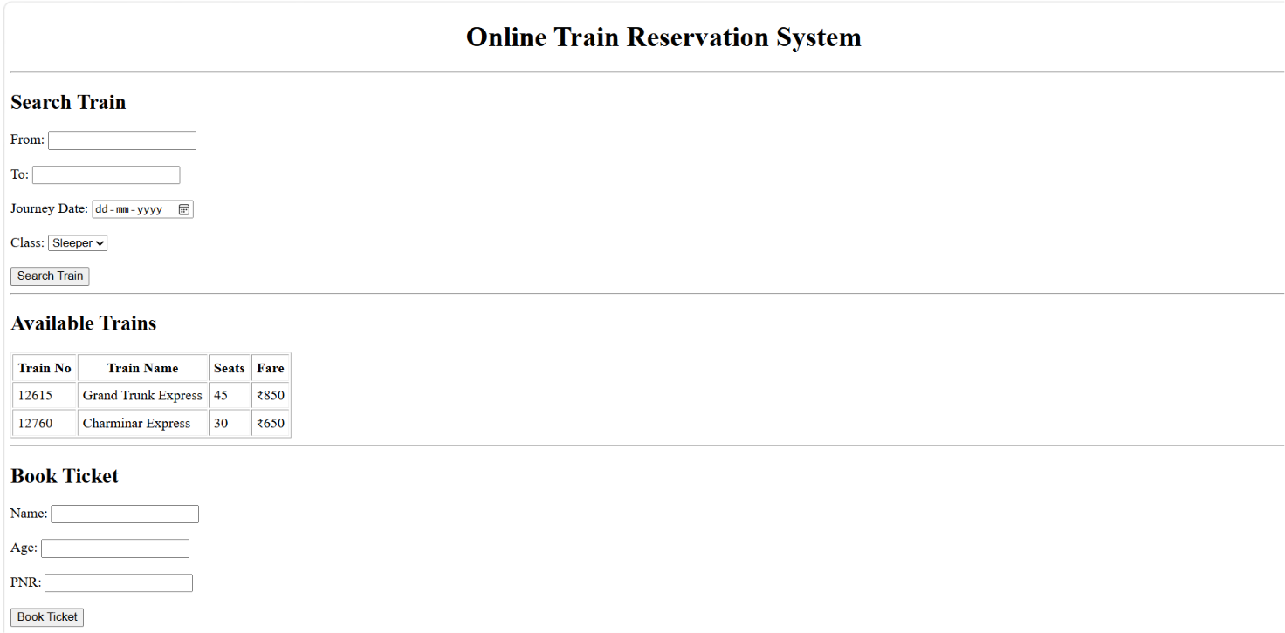
5. The online flight reservation system enables users to search for flights by destination, date, and class, displaying available options with real-time seat availability. Users can register, log in, and manage their reservations via a personal dashboard. The booking process includes selecting flights, choosing seats, entering passenger details, and making secure payments through an integrated payment gateway. Admins can manage flight schedules, seat inventory, and user accounts using an advanced admin panel. Users receive booking confirmation emails with e-tickets and can view their booking history and travel itineraries. The website is fully responsive, ensuring an optimal experience on all devices.The airline reservation system is a web-based system that helps in consolidating flight data - flight schedules, seat availability, flight fares and reservations from all airlines with the help of global distribution systems and provides real-time inventory and rates for customers and travel agents to book flight tickets online.
Source Code:
<!DOCTYPE html>
<html>
<head>
<title>Flight Reservation System</title>
</head>
<body>
<h1 align="center">Online Flight Reservation System</h1>
<hr>
<h2>Search Flight</h2>
<form>
From: <input type="text"><br><br>
To: <input type="text"><br><br>
Date: <input type="date"><br><br>
Class:
<select>
<option>Economy</option>
<option>Business</option>
<option>First Class</option>
</select><br><br>
<input type="submit" value="Search Flight">
</form>
<hr>
<h2>Available Flights</h2>
<table border="1" cellpadding="5">
<tr>
<th>Flight No</th>
<th>Airline</th>
<th>Seats</th>
<th>Fare</th>
</tr>
<tr>
<td>AI101</td>
<td>Air India</td>
<td>25</td>
<td>₹5000</td>
</tr>
<tr>
<td>6E202</td>
<td>IndiGo</td>
<td>18</td>
<td>₹4500</td>
</tr>
</table>
<hr>
<h2>Book Ticket</h2>
<form>
Name: <input type="text"><br><br>
Email: <input type="email"><br><br>
Seat No: <input type="text"><br><br>
<input type="submit" value="Book Ticket">
</form>
<hr>
<h2>Payment</h2>
<form>
Card Number: <input type="text"><br><br>
<input type="submit" value="Pay Now">
</form>
<hr>
<h2>Booking Status</h2>
<form>
Ticket ID: <input type="text">
<input type="submit" value="View Status">
</form>
<hr>
<h2>Customer Feedback</h2>
<textarea rows="4" cols="30" placeholder="Write your feedback"></textarea><br><br>
<input type="submit" value="Submit">
<hr>
<h2>Print Ticket</h2>
<button>Print Ticket</button>
</body>
</html>
Output:
